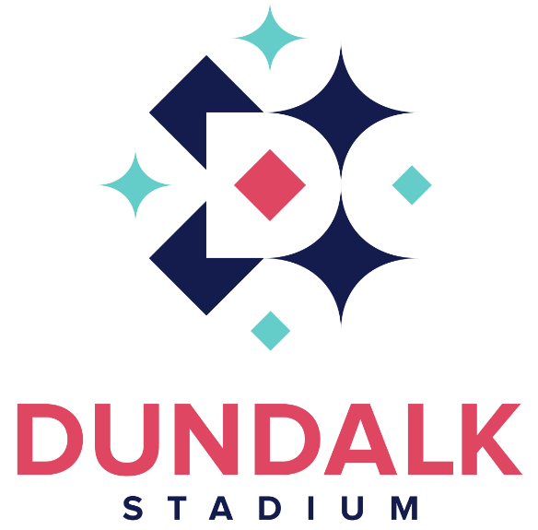

Roast vegetable soup (3)(8)

Smoked salmon roulade
(1)(3)(10)(11)(13)
Served with capers & a tartare sauce

Garlic mushrooms (1)(3)(10)(11)(14)
Served with a mixed leaf salad
& a garlic mayonnaise

BBQ baby pork ribs (3)(6)(8)(14)
Served with an Asian slaw
& topped with wasabi sesame seeds

----

Grilled Irish sirloin steak (1)(3)(8)(10)(11)(12)
Cooked to your liking
Please allow 20 mins for well-done steak
Served with a pepper sauce, onion rings,
roast tomato & asparagus
€5.50 supplement

Chorizo stuffed chicken supreme (3)(8)(11)
Served on a bed of mashed potato with a vegetable bouquet & topped with a garlic butter

Salmon and prawns (3)(7)(8)(11)(12)(13)
Served on a bed of mashed potato with a vegetable bouquet & topped with a white wine sauce

Moroccan chickpea stew (3)(8)(12)
Served with basmati rice

----

Lemon tart (1)(3)(5)(10)(11)
Served with fresh cream

Crème Brûlée (1)(5)(10)(11)
Served with a shortbread biscuit

Biscoff cheesecake (1)(3)(5)(11)
Served with fresh cream

Selection of Irish cheese (1)(5)(11)
Cahill’s Irish porter, brie, Cashel blue
Served with an apple chutney, fresh grapes
& crackers (Add a glass of Sandeman port for €4)

----
Tea or Coffee
(Upgrade to an Irish coffee for €4)

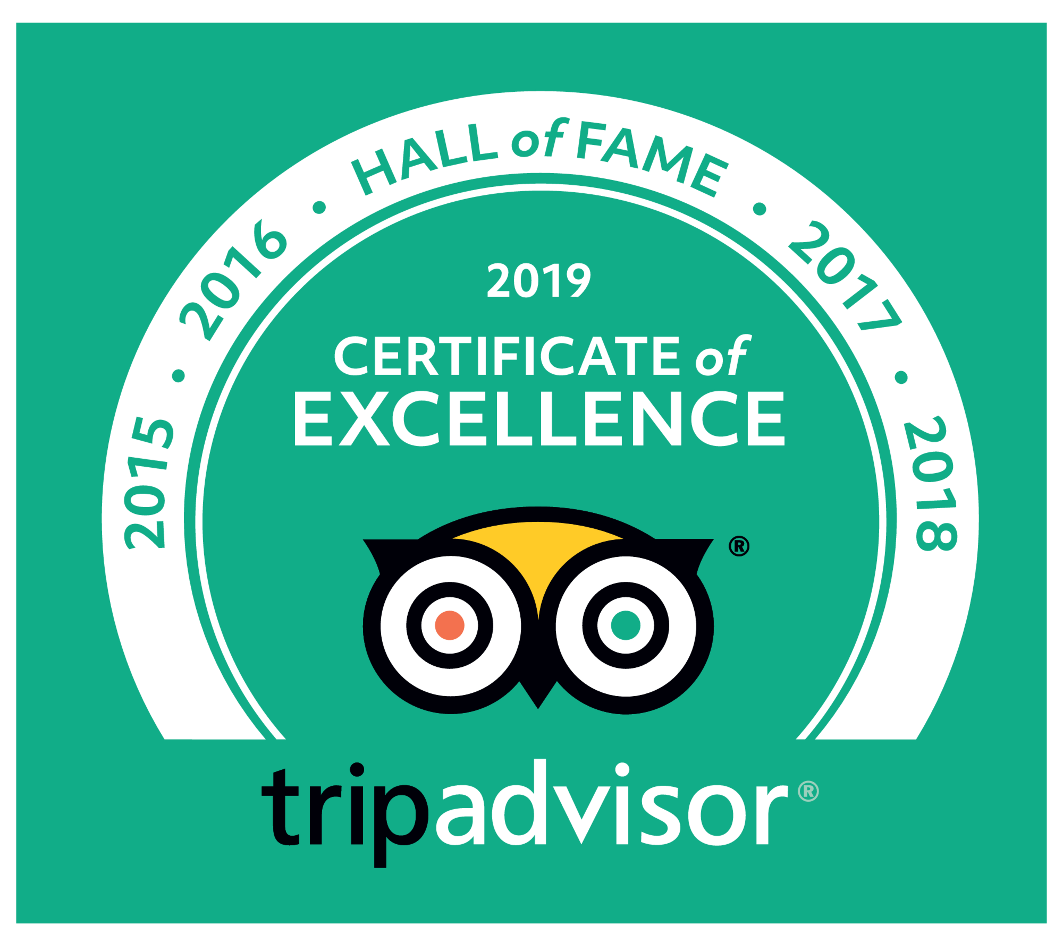

Welcome to
Dundalk Stadium

The View Restaurant

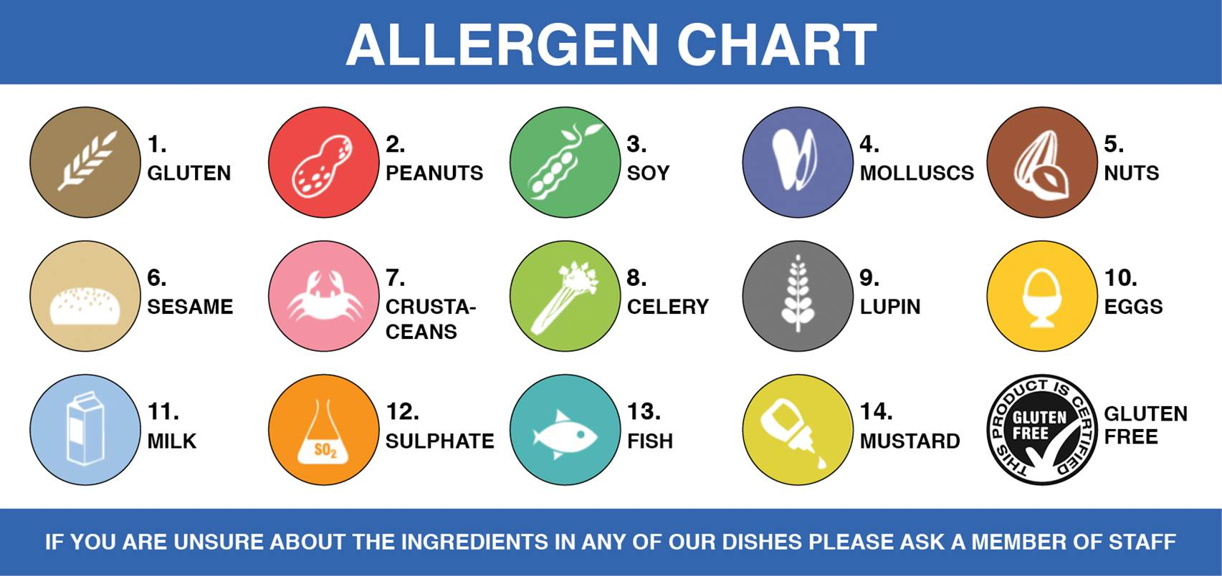

Here at The View restaurant, we endeavour to ensure all our produce is locally
sourced whenever possible. All our meat, fish and poultry are supplied by
Bord Bia and Seafood NI approved suppliers and are fully traceable from the
farm or sea to the plate.

Fresh Irish chicken (deboned in house) from Tony Kierans Ltd. Dundalk, Co Louth
Mature Irish sirloin beef supplied by Ashbrook Meats, Knockbridge, Co Louth
All our beef is 100% Irish and traceable
Fresh Irish seafood from Narrow Waters, Omeath, Co Louth &
Mourne Seafood, Kilkeel, Co Down
All fruit & veg is supplied by Fan Fruit, Dunleer, Co Louth

